**ELEKTRONİĞE GİRİŞ_METİN YAZGI_2.ÖDEV**

1. **ÖDEVDE ANALİZLERİ YAPILAN AŞAĞIDAKİ DEVRELERİN SPICE SİMÜLASYONLARINI YAPIN.**

**1.**For the circuit in Figure 1, transistor parameters for T1 and T2 are VA1=VA2=∞, ΒF=βf=80, VT=26mV and VBE1=VBE2=0.7V. (Vcc=5V, R1=12kΩ, R2=18kΩ, RC=220Ω, RE=1kΩ)

1. Determine the DC collector current for BJT.
2. Find the small signal voltage gain V0/Vin.
3. Determine the input and output resistances.

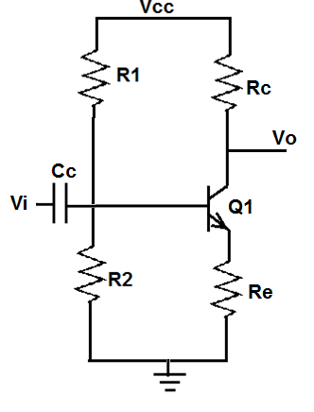

**Figure 1**

**2.** For the amplifier shown, find the voltage gain, input resistance and output resistance. (K= 1 mA/V2; Vth = 2V; λ = 0.001V-1)

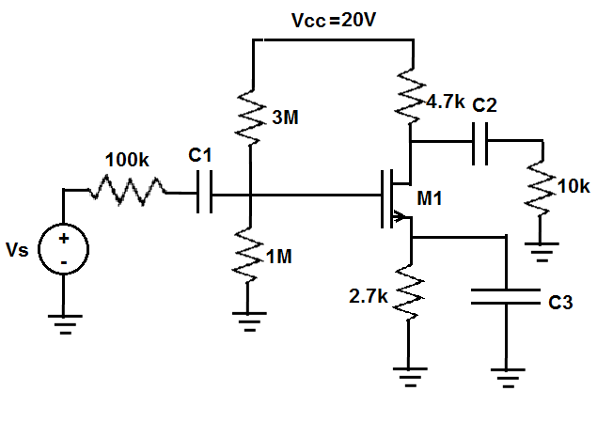

**Figure 2**